West Hull Ladies
RRC

September Newsletter

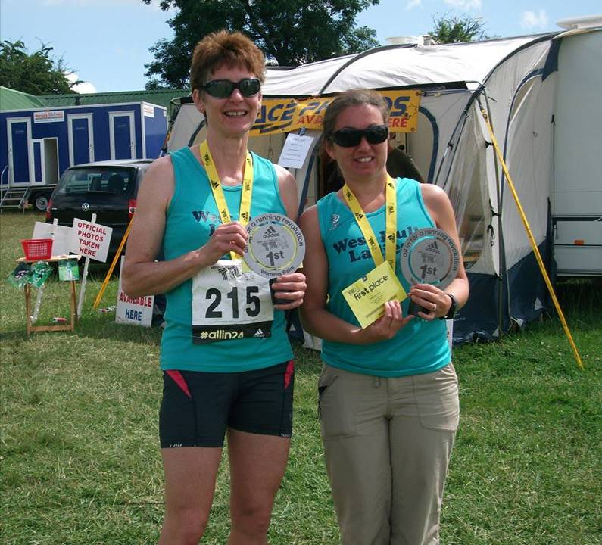

West Hull Ladies
Well done to Amanda and Verity for winning the Thunder Run ladies pairs

WEST HULL LADIES RRC
COMMITTEE MEETING

September 2nd 2013
Minutes

Present: Jill, Linda, Ann, Sally, Rachael, Debs, Zoe, Amanda, Sandra, Andrea

- Apologies from Verity, Annette, Shem, Debbie
- Minutes of previous meeting 1.7.2013 agreed
- Amanda had completed form for HSP.
The sports club had reduced rental to £400 per annum.
Sandra had not sent email about track sessions but would do so to gauge interest.
Maria and Jill were attending LiRF course soon – to be discussed re further leaders at next meeting.
Pilates evening had been successful and raised £91+
Proposed BBQ cancelled.
Zoe had made enquires re calling cards for club – to progress further.
No update from Sarah T re kit from Arco.
- As at 3 – Maria and Jill attending.
- Amanda gave a run down of the Yorkshire Vet series and enough ladies seemed interested so we would pursue for next event when known.
- Rudolph Romp – to be held first Sat in December, Amanda described event and committee agreed dates for when recces could be held. ACTION – Amanda to send email to all with dates when recces of the course would take place.
- Discussed 10K series and agreed that the series would allow times for off road runs providing it was not the first recorded one of the year.
- Improvers of the Year. Discussion took place about the difficulty keeping records for each individual and what an onerous task it was for anyone to take on board. ACTION – sub committee consisting of Jill, Ann, Sandra, Rachael and Zoe to meet and discuss awards and administration of such. To report back to committee.
- Amanda stated that she was going to enquire about holding a coaching session for University Students as a good advert for the club and to possibly charge a fee for this. ACTION – Amanda to progress and report back.
- Kit – Maria updated that there were now more hats for sale. Ladies spoke of maybe having long sleeved vest and maybe running jacket in club colours. ACTION Sandra to make enquiries with ARCO and see what they could provide and cost etc.
- Debbie had reported profit from Pilates evening and reduction in rental although this still needed to be confirmed in writing. NOTE – Now confirmed in writing
- Nothing to report from HAN
- Sally reported that the Club had been allocated 1 place in London Marathon – ladies who were unsuccessful in their application must keep hold of their ballot paper if they wished to enter the club draw. It was thought that if we had 3 more club members we would be allocated 2 places. ACTION Sally to confirm.
- Maria offered to run several walk and run sessions for ladies who had not been to the Club for a while. This would hopefully encourage these ladies to return to continue their running. Everyone thanked Maria for taking this on board. ACTION Maria to progress.
Amanda asked if anyone was willing to take on board the calendar update for the Clubz website the club was registered on – no-one wanted this and Annette to carry on (many thanks)
Zoe showed members a logo she had designed for the Club following a conversation she had had with Verity. This was accepted and would be used on letterheads etc. when completed.
Sally reported that she had received correspondence from England Athletics but the only thing to concern us was the Affiliation fee rising to £75 per year.

The next meeting was scheduled for 7th October 2013.

Thunder Run

Amanda
On arrival I was disappointed in the Thunder Run. It is massive now – 2,600 runners with plus around 5,000 along for the jolly – families, friends etc. I think there were around 600 when I did it 3 years ago and it has changed how it feels. It was much cosier on my first visit and felt we all became a team, too large for that now. On top of that, a little better organisation would have helped e.g. a sign for the registration tent.

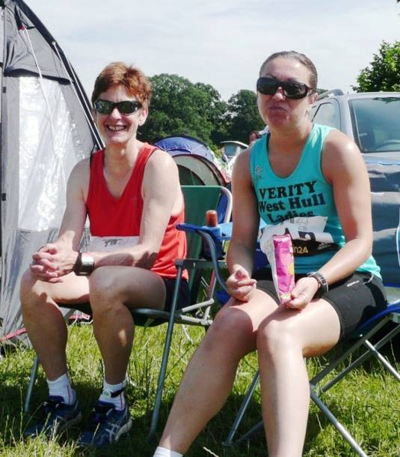
However, the race itself is the same and we got a great pitch by taking up some of the solo runners space so that was positive and after getting the tent sorted and plenty of drink it was down to preparing to go and run.

This time, the Thunder Run was extra hard due to very difficult conditions. The 1st 2 laps (10K a lap) were in baking heat but that was fine, just needed to drink lots. But on lap 4 the torrential rain (with the interest of thunder and lightning) started and within 20 mins it was a mud bath. The rain continued for 8 hours and the course never recovered. The mud was clay-like very slimy and as most of the paths had a camber you slid off sideways. The white washed roots and rocks were a waste of time as obscured by mud within minutes and my trainers were soon heavier than my walking boots.

I had been excited about finding my limit. When will I stop? Will it be because I am physically destroyed or, more likely, in mental anguish! I had asked Verity if she would partner me because I knew from Rudolph Romps and her marathons she is mentally very strong resulting in achievements which go beyond her training. I thought she might be stronger than me.

So, I am at the start and the reality starts to kick in with miles and miles ahead of you. I was nervous. Take it a lap at a time. I hope I don’t embarrass myself. Then I was off and between nerves, enjoyed my lap which, despite taking it easy was over in just under 52 minutes and the ‘baton’ was passed to Verity.

At the end of each lap, Neil was there handing us drinks and leading us back to the tent, encouraging us to eat and rest. Without Neil I could not have done this. A very exhausting time for him too, not enough sleep and constantly on the move sorting us out. The other thing I was trying to do between laps was to stretch to avoid stiffening up and getting an injury. As I became more tired I was less inclined to move at all!

A number of warm laps passed. From lap 3 we were in the lead for the ladies pair, I was surprised but not taking it seriously as this was very early to be considering a win. I headed out on my 4th lap (6pm) and the rain started, quite pleasant at first but then very heavy and the route became a quagmire. The next couple of laps were slow. Then Verity headed off into the first fully dark lap and arrived back in tears having spent most of the course worried about getting lost as her head torch was reflecting back off the rain. This was 10:40pm and I had heard the rain was due to stop at 4am so told her to get back to the tent, get out of sodden clothes, eat, drink, set her alarm for 4 and go to sleep. I joined her after an interesting lap!! Neither of us slept but it was nice to hear the driving rain and not be sliding about in mud!

We both got up at 4am, the sun was coming up and the rain had stopped. I offered to run first as Verity had been so distraught at the end of the ‘dark lap’ but she quickly got sorted and was out on the route for 4:15am and returned in good spirits.

I headed out for my 7th lap. It was tough. Verity out again and dealing with it very well. At the end of my 8th lap I handed over the ‘baton’ telling Verity I might not be able to go again. I was physically and mentally weary. Could I drag my legs out onto the route again? On my 8th lap I had chatted with a solo runner who said “I would be disappointed if I stopped and could have done another”. I really was not sure about that. It was Verity’s upbeat message that made me get my legs into gear. It was very hard and took me 82 minutes. Lifting my heavy trainers and heavy legs required a lot of determination. Even walking was tough.

Neil, Verity, Jill and Zoe were waiting at the end. I knew the second female pair had also done 17 laps so it was down to time. Neil checked the board and returned to say we had won by 14 minutes. I was so tired it didn’t really sink in and I suddenly found myself getting a bit overcome and headed back to the tent gulping tears. So... I went out to find my limit. I thought I found it, but I am a bit concerned that was only July’s limit. Isn’t that annoying? I might have to find another limit!

Now feeling proud.

Got a lovely medal and trophy and £80 worth of ‘eyewear’. I think that will mean a pair of sunglasses but hoping it will be changeable lenses which will be great for cycling.
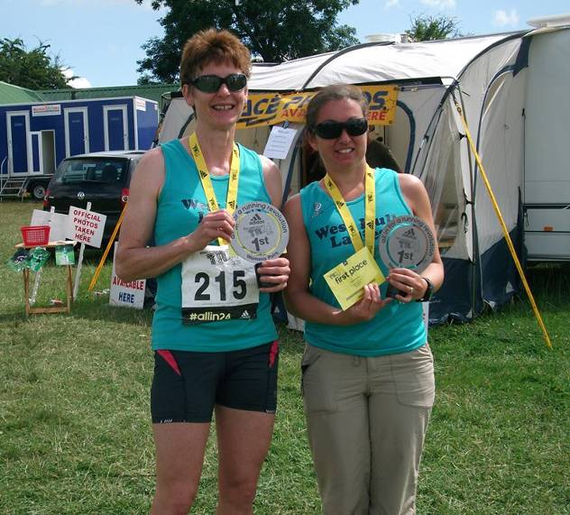
Just for interest, I ate well: 4 x bananas, 2 x cereal bars, 2.5 small Cornish pasties, a bowl of spaghetti bolognaise, 2 bags crisps, 1 very small sandwich, some muesli, ginger cake plus downed over 4 litres of recovery drink plus water, tea and coffee.

Would I do it again? Good question J

Verity
I was nervous when we arrived at Catton Park, Derbyshire, the setting for The Adidas Thunder Run, 2013. We met up with Zoe, Jill and Michael – our support team - and set up camp near the start line. The race started at 12 and it was a nervous wait for Amanda to do the first lap, and it was hot, really hot. I was disappointed that I found the first lap hard. I told myself that I was only walking the hills because I was saving myself for the later laps but the truth is that I was already struggling. I tried to drink, eat and stretch during my break. I got the boost I needed as the commentator announced that we were in the lead and laps 2, 3 and 4 were much easier; I picked out bits to walk and where to start running again.

The end of lap 4 was when the fun started. We knew a storm was heading our way but there was a little part in all of us, I think, that hoped it wasn’t going to happen. As I passed the 8K sign, the thunder and lightning started and by 9K the heavens had opened. Trail shoes and head torch were at the ready for lap 5. At first lap 5 was quite fun in the rain and the dark but it didn’t take long for the novelty to wear off. The rain had already turned the paths into mud slides. My head torch was doing its best but with the torrential rain and thick forest all I could really see was a misty metre in front of me. I tried to stay close to other runners and their industrial-strength torches but I couldn’t keep up! By the time I came out of the forest (8K) I had had enough and I was in a bit of a state by the time I passed the baton to Amanda so I called it a night.

My alarm went off at 4 and it had stopped raining – hooray! I was out on lap number 6 by 4:30. It was hard, really hard, really really hard. The paths were ridiculous; I didn’t know how I was going to do it without falling over! The lap took around 90 minutes and I felt dreadful. I told myself, “I can do one more.” Then Neil told me that we were still winning. Oh no! Selfishly, I was hoping that another pair would have braved the night and overtaken us so we didn’t have to compete anymore, but no, everyone had done the same as us so the title was still ours for the taking.

Lap 7 was much, much better. Another runner asked me what lap I was on, when I said 7, she said, “Wow! 70K that’s amazing.” I said, “No, it’s not that far... no, wait a minute, of course it is!” It was the boost I needed to get going. I finished lap 7 knowing that I could do lap 8 and quite excited by the idea of being able to do nearly 50 miles. When Amanda handed over to me again after her 80K she said, “I don’t think I can go again.” I didn’t believe her! I was very emotional on that last lap. When I reached the last corner a crowd had gathered in the sunshine and I burst into tears as they cheered me in! A lovely Adidas Team runner ran the last hill with me – I was fine – just utterly and completely shattered!

It was no surprise that Amanda was ready for lap number 9 when I got back to the start. We had been under the impression that we were way ahead but another pair was actually matching us lap for lap because their timing chips weren’t working properly. When Neil checked the result screens for the last time we were only 7½ minutes ahead of them. It was a tense last hour but Amanda did it. Her 90th kilometre in a time of 84 minutes meant that we beat the second placed pair by 15 minutes. As well as a medal and a t-shirt, we got a great trophy and a voucher for a pair of Adidas sunglasses. After getting home I very much enjoyed a pizza, lots of chocolate and an early night!

A huge thank you to our support team. It was great to have Jill, Zoe and Michael there cheering us on and looking after my feet and legs! Neil was fantastic – meeting me at the end of every lap with food and drink and making sure I had everything I needed. He also put up with a rollercoaster of my emotions! Finally, thank you to Amanda for asking me to team up with her. She knows I love winning!

Jane Tomlinson York 10k

Jill
Just done JT10k at York. Even though I didn't get a PB was quite pleased with my run as this appeared to be quite a generous 10k distance. My Garmin said 6.32 miles...so perhaps I ran the long way around!! My chip time was 52:54, which was higher than my PB which was 52:35 at Beverley, but my average speed was faster, as were my mile times (8:22 at York in comparison to 8:35 at Beverley). I was also quite consistent with my running which as pleasing with all splits being in 8 minute bracket. It was a bit hot at the beginning...but then the sun went in and it became a bit windy. I ended up tipping my water bottle over my head and down my back, which was fine except I looked as though I had wee'd myself as it showed up really badly on my blue shorts!!

The course was better this year as there were no sections where you had to turn back on yourself, but the toilets (as usual) were rubbish. The queues were ridiculous...so I ended up weeing in the trees near to the race course (I am now good at this from having to do it at the champagne league lol!). They were a bit stricter about getting people into the correct starting area, which was much better, so you didn't fall over everyone at the start, although the instructions were a bit confusing. Zoe seemed to run quite well and was 96th woman out of 2101 women on place time. I think that she was really pleased with that...as she should be! I was 173rd out of 2101 women which I was well chuffed with. I know that a lot of runners that do these types of events are not team members, but I was still pleased. I saw Sally on the course, who ran really well as she started right at the back so had to fight her way through... she came storming past me and caught Zoe up. Well done to Kayleigh and Clare on completing their first 10k...awesome! I think Clare did a really good time for her first race too. All in all a good day at the races!

Zoe
Over the last few months I have lost my appetite for racing and couldn't wait for it all to be over so that I could start to enjoy running again. For this reason, having to drag myself out of bed at 6 am on a Sunday morning to run the JT York 10 km race filled me with dread.

Waiting at the start line for the race to begin I had already decided to take Sandra's advice and not to go for a PB but instead try to enjoy the race and get some confidence back. I was surprised how fast I reached the 1 km marker (I was battling through crowds as I came across bottlenecks in the course) and soon got into a good rhythm. It was not a fast first mile at 8:13 but it was comfortable and I was enjoying passing people. The second mile was better (7:42) as I ran towards the centre of York. I then had a bit of a bad patch (there must have been a hill, lol!) but at this point Sally passed me and encouraged me to speed up - as I am quite competitive I couldn't let her pull away. Running through the shopping streets I was reminiscing about when I used to live in York and looking to see if my favourite bars were still open (I was very tempted to stop for a rest as we passed the Lowther Pub but didn't have any money for a drink). I had another bad patch when we ran down onto the riverside path where I could see lots of runners ahead and where the ground became a little rough in places, but whenever I said that I wanted to slow down Sally told me to breathe deep and keep going. Running up towards Millennium Bridge I suddenly realised that I only had about 1 mile to go so found some speed and started to enjoy the run again. The last part of the course was tough as there was a hill running up to the finishing straight and the finish was a lot further down the road then I remember from last year (still, there were no horrible bits where you had to turn back on yourself this year!). I didn't manage a fast sprint however I concentrated on my style over the last few hundred meters and found that I sped up and started running in a nice fluid rhythm (If only I could do that for the full race!).

Although I didn't get a PB (chip time 49:13), I did feel satisfied that I had tried my best and enjoyed parts of the race as well as having got some confidence back in my running. A big thank you to Sally for putting up with my silly comments and helping me keep going! Now I can concentrate on my marathon training and get back to doing my favourite speed work sessions. ☺

Escrick 10k

Linda
Four West Hull Ladies ran this 10k, Sally, Yendis, Kayleigh and myself. I didn’t even have to drive to the event as Kayleigh picked me up and Sally was with her too, what lovely ladies you all are, thank you, very much appreciated.

If you want a lovely off road course which is flat and sheltered from the sun this is definitely the course for you. No road work whatsoever. The organisation of the event was wonderful. On the village green there were tents and BBQ’s available (for the spectators as I don’t think many runners were buying burgers or bacon butties)!

My aim on this event was to try and beat my PB of just over 57mins. So I knuckled down and tried to keep at an even pace without speeding up and slowing down at any point! Not easy. Just after halfway and running through a section in the woods I could see Kayleigh running she looked so happy and gave me a wave as she made her way to the water station. The woods were beautiful to run through.

Finally I was close to the finish, just 1k to go. You just can’t imagine how tired my legs felt (or maybe you can) but I kept an image in my head of Amanda shouting encouragement so kept the pace up, finally I could see Sally clapping and cheering and the finish line was in sight, hooray I made it.

The worst part was my super duper Garmin watch thingy (which I’m still getting used to), didn’t pick up a signal for a while, it actually showed that I had ran only 5.78 miles at 52.08 so I had to wait for the official results to see what I’d managed to achieve (although Sally said she could see the finish clock and I’d done 55 something)! I didn’t want to believe her so I wouldn’t be disappointed. Anyway we had to wait for the results which weren’t ready until Tuesday and yes I made it, 55.38 I was well chuffed.

We waited at the finish line to cheer in Yendis and Kayleigh. Kayleigh was completing her first 10k and she ran all the way. Seeing her lovely, happy smiling face coming into view was wonderful as we cheered her to the finish line. She had been so nervous but I know she loved it and will now enter some other races. Well done Kayleigh.

So again thanks to all you West Hull Ladies for helping me get there.

Vitruvian Triathlon

Ann
This was at Rutland Water, Leicestershire. We met a handful of pirates for food at a local pub the night before then camped on site. I left Anders and Carol sleeping while I quietly downed the routine porridge and banana and then headed off for the swim.

Swim – 1900 metres
After Outlaw I wasn’t intimidated by this event, but that backfired a little, because at first I didn’t feel hyped up enough for the event. A part of me just wanted to go back to bed, and I didn’t enjoy walking to the water’s edge in bare feet – I’m sure that should be part of a triathlete’s training schedule – not looking a wimp tip toeing to the water...

This was a wave start, and the ladies were last to go. We waded in for a deep water start, or should I say weed water start – some ladies looked like the creature from the black lagoon, as they were covered with weeds! No worries, weeds won’t attack me, or try to drag me under the water to drown me – man up, and get going, Ann.

The hooter sounded and off we went, into the sun, again, just like at Outlaw, only this time we had to do two laps. The swim seemed to go on forever at first, and I was very wobbly getting out of the water to start the second lap, but then I started to get into my rhythm a bit better, and hitched a lift most of the way back from another swimmer – always a bonus.

48 min for the swim – one minute slower than the Rubicon last year, but that was down river and didn’t involve getting out of the water half way through, so that was fine.

Bike – 52 miles
Quick transition (for me, about 4 minutes) and then off on the main challenge of the day, a hilly two lap course around Rutland Water. I’d trained well for this around the Wolds, and although I hadn’t done more than 43 miles in training since Outlaw, this was enough. As always, I got overtaken quite a bit going up the hills, and then overtook others on the flat and going down. The worst part of the day, though, was needing a wee – we’d been told at the beginning that anyone caught urinating in public would be arrested and could be placed on the sex offenders register!!! So I spent quite a few miles weighing up a urinary infection (exaggerating, I know) against losing my job ... until coming into the race HQ at the end of the first lap and a welcome toilet visit...

Starting the next lap took some commitment, since most men (who’d had a head start, remember) were finishing their bike leg as I was starting the second lap. Still, the miles came and went, and with NO PUNCTURES WHATSOEVER, I came into T2.

Run – 13.1 miles
This was twice along an out and back route beside the lake. In contrast to the lonely bike route, there were lots of people around at this point – families out for a bimble around the lake, supporters, and other competitors running the other way. Lots of support for the pirates, of course, and I gave everyone a jolly big “arrrgh” in return. I loved the run – smiled all the time, because I felt strong and knew I was keeping a good pace.

I finished the run nearly 13 minutes faster than Rubicon last year, which was flatter. As this event was more a training exercise than a major challenge for me, I was more interested in what I could produce on the run, really, as long run training for Snowdonia next month. I was delighted to feel so happy just putting one foot in front of the other!

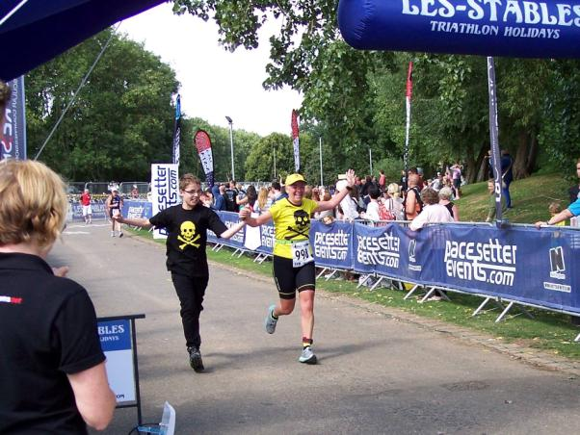
Happy to be able to run with my son to the finish line again!

Final finish time 6.15 – jobs a good ‘un!

Champagne League Presentation

Carol
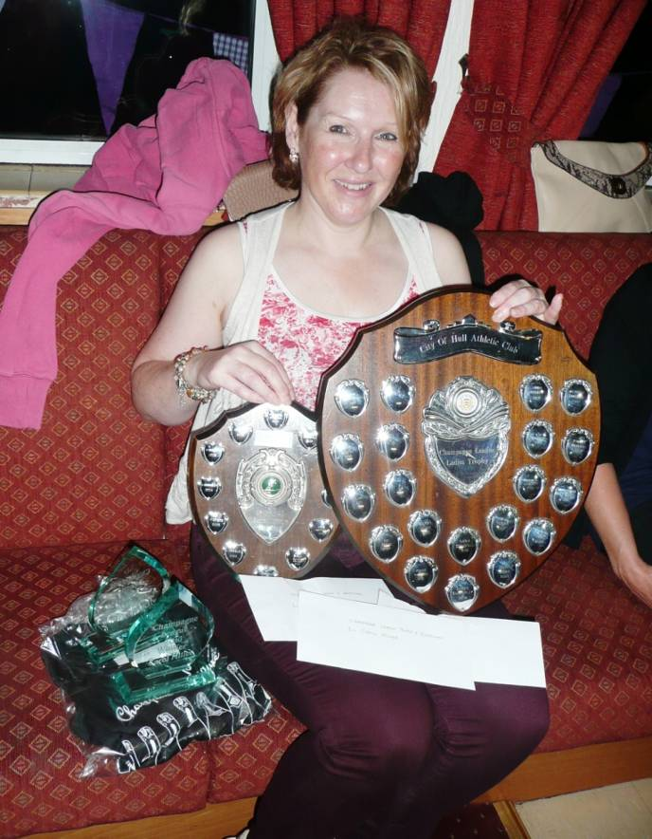
It was lovely to catch up with the ladies Amanda, Jill, Zoe, Verity, Kate, Suzanne and Maria (hope I haven't missed anyone) and the BBQ was very nice!

I still can't actually believe I won the handicaps and was very overwhelmed by the size of the ladies trophy, actually no it isn't a trophy, it's a shield! Finding a place for said shield was a little tricky but it is on display for the next year. I also won £115.00 in prize money which I have bought some new trainers with ready for my return to the club which may be for the next coaching session (will await to see how my next session with Jamie Barrington goes).

I would just like to thank everyone for their support and encouragement once again. I wouldn't have got through the full series without it. I'm so glad I didn't throw the towel in half way through with my injury. To think I was only doing this for the t-shirt!

Amanda
Jill, Zoe, Maria, Kate, Verity, Suzanne, Carol and I (plus Adam, Simon and Gregan) went to the presentation evening. The food was very nice steak, sausage, chicken. The vegetarian food looked excellent aubergine slices with melted cheese, vegetable kebabs and vegetable burgers. There were also new potatoes, french bread, salad and coleslaw.
Carol was the star of the evening, putting West Hull Ladies in the lime light, taking first prize in the main and ladies handicap and receiving two massive trophies to keep for the year and glass trophies to keep forever. She took a stack of cash to which was added the LV40 Yellow Jersey prize.
There were fewer prizes this year so not as many West Hull Ladies as hoped went home with a prize and no bottles of wine! ☹
Only 3 team prizes (last year 5 team prizes).
Only 3 yellow jersey main prizes (last year 5 main prizes). This meant that, as I was in 4th place, I took the LV50 prize (sorry Debbie).
Sally and Zoe had already received their prize for winning a race on handicap and everyone who ran all 10 races received a T Shirt i.e. Carol, Jill, Zoe, Debbie, Verity and me.
If you got nothing else out of it you had great running training in lovely surroundings and met like minded people.
Over all a positive champagne league yet again with 4 of the 11 West Hull Ladies taking prizes. Well done ladies.
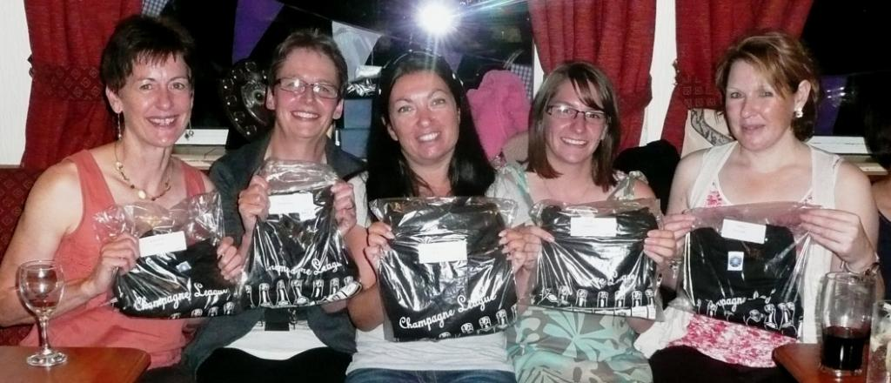

Selby 3 Swans 100k Sportive

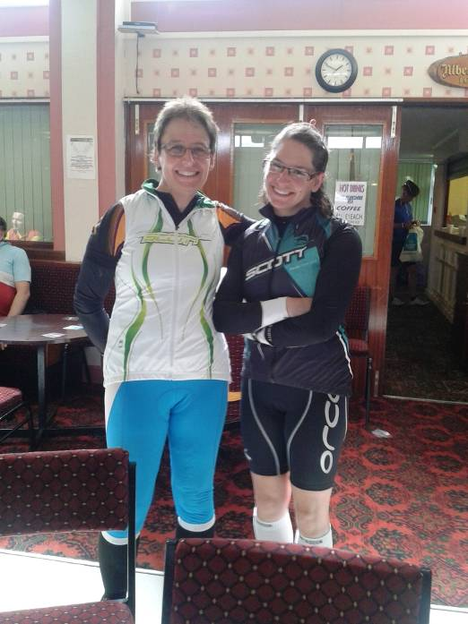
Jill
Enjoyed doing the Selby sportive with Zoe and Debs. Debs is a fab cyclist particularly up the hills where she is awesome! Zoe did really well as the furthest she's been before today is around 60k, and today she did 100k. It was quite windy and the middle bit was a bit undulating to say the least!

Carol
Myself, Jill, Zoe and Deb entered this sportive along with some of our Sunday Girl Road Club members. I really enjoyed the route on this ride passing through some beautiful villages around Selby that I didn't even know existed. The wind made for a tough ride throughout and was pretty brutal in places (not a little windy as Jill would have you believe!). I completed it in 3:59 (under 4 hours please note) along with my riding partner Catherine from SGRC.

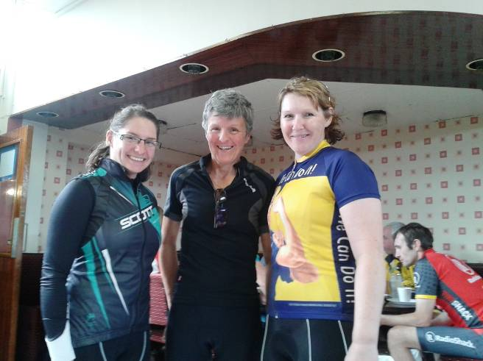
The star of the show has to be Zoe with I believe a time of 4:19 along with Jill and Deb. This was Zoe's longest ride to date, with the wind and around 15 miles of an undulating section. I did laugh when I asked how the ride went. Zoe replied with 'don't ask me'! Zoe informed me she hadn't cycled since the Big G in July. So well done Zoe you did fantastic and well done also to Jill and Deb.

Racing and Running Events
Fancy something different? For worldwide marathons click here

Date/Time | Event | Fee | Entry forms | Online entry
September 2013
8th/10:00 | Major Stone Half Marathon | £15 | Entry form | Online entry(+£1@UKforms.net)
22nd/10:30 | Burton Pidsea 10K | £6 UKA/£8 | Entry form | No online entry (that I could find!)
22nd/10:30 | Stainland Trail 10K | £10 UKA/£12 | Entry Form | Online entry (+£1.50)
22nd/10:00 | Kirkstall Abbey 7 (6.7 miles) | £8 UKA/£10 | Entry Form | Online entry (+£1.40)
29th/11:00 | College Canter (7 miles) | £8 UKA/£10 | Information | Online entry
29th/10:00 | Redcar Half Marathon | £22.50 UKA/£25.50 | Entry form | Online entry
October 2013
5th/09:00 | Round Ripon Ultra (35 miles) | £39 or free if you run for Teach Africa | Entry form | Online entry(+£1@Ukforms.net)
13th/11:00 | Wistow 10K (near Selby) | £8 UKA/£10 | Entry form | Online entry(+£1.40)
20th/12:00 | Bridlington Half Marathon | £12 UKA/£14 | Entry form | Online entry(+£1@Ukforms.net)
27th/11:00 | Haltemprice 10K | £7 UKA/£9 | Entry form | No online entry
November 2013
3rd/11:00 | Deepdale Dash 10K | £10 UKA / £12 | Entry form | Online entry
3rd/10:00 | Yorkshire Coast 10K (Scarborough) | £11.50 UKA/£13.50 | Entry form | Online entry
3rd/10:30 | Nid Valley Guy Fawkes 10 | £12 UKA/£14 | Entry form | Online entry
December 2013
7th/08:30 | Rudolph’s Romp | £10 | Entry form | Postal entries only
26th/10:30 | Boxing Day 10K | £4 UKA/£6 | Entry form | Online entry (+£1.40)
March 2014
9th/10:00 | East Hull 20 | £18 UKA/£20 | Entry form | Online entry (+£1.80)

Keep checking the website for new races and updates: www.westhullladies.org.uk/races.htm Verity, Racing Officer

NOTE: Club Vests must be worn at any races you enter
under the West Hull Ladies running club name.

Clubwear
PRICES:
Vest | £16.00 | All items are ordered on request and must be paid for at time of ordering. To place an order please print the kit order form and hand completed forms to Maria.
T- shirt | £16.50
Hoodie | £14.00
Jacket | £32
Beanie Hat | £6.50



New Club Jacket available in three sizes: small, extra small, and junior (large fitting). If you would like to purchase one please send a cheque for £32 to Debbie Watson, Treasurer, and state on the back of your cheque your name and that the cheque is for a jacket.

Jill

Running Library

You can borrow any of these books – they are upstairs near the toilets at the end of the corridor
Book List:
- The Runner's Diet (Runners World), Madelyn H. Fernstrom
- Paula My Story So Far, Paula Radcliffe
- The Runner's Handbook, Bob Glover
- The Competitive Runner's Handbook, Bob Glover & Shelly Lynn Glover
- Marathon Running For Mortals, John Bingham

- Lore of Running,

Running Magazines: These are available to borrow by emailing the club website.
Mark your email for the attention of Jo.

West Hull Ladies Road Running Club
Kit Order Form

FORENAME ___________________________________

SURNAME ___________________________________

ORDER - tick what you require, with size Price

- VEST SIZE _____________ £16.00
- T SHIRT SIZE _____________ £16.50
- JACKET SIZE _____________ £32
- HOODIE SIZE _____________ £14
- BEANIE HAT £6.50

DATE Ordered _______________

AMOUNT PAID _______________

Please make Cheque payable to ‘West Hull Ladies’
Write your name and order on the back.

Sign on receipt of goods _________________________________

DATE _______________

Please print this form, complete and hand to me with your cheque/cash.
Thanks.
Maria
Kit Officer

